Dealing with Objects

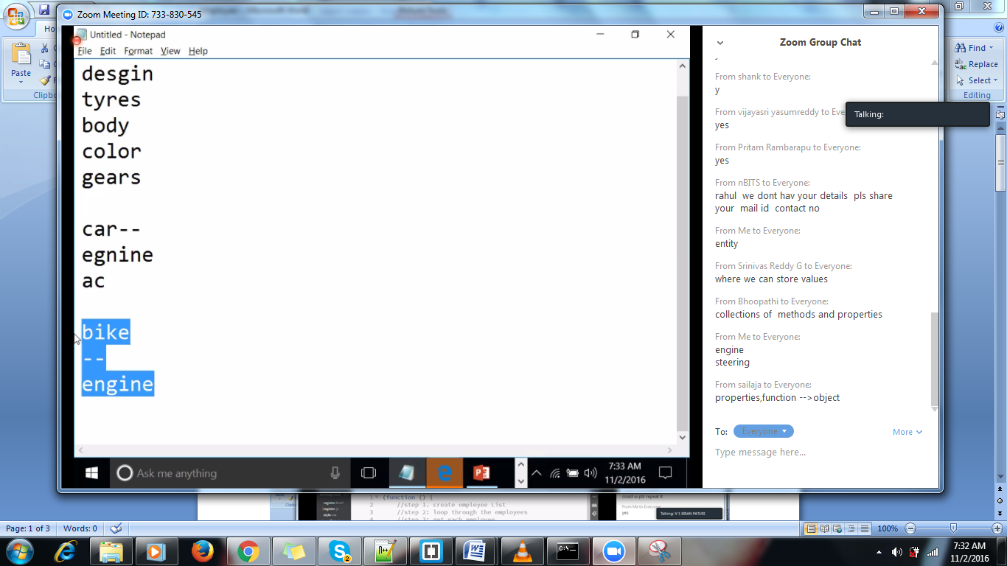

Immediate invokable function () ();

//object literals.

Var vehicle={}

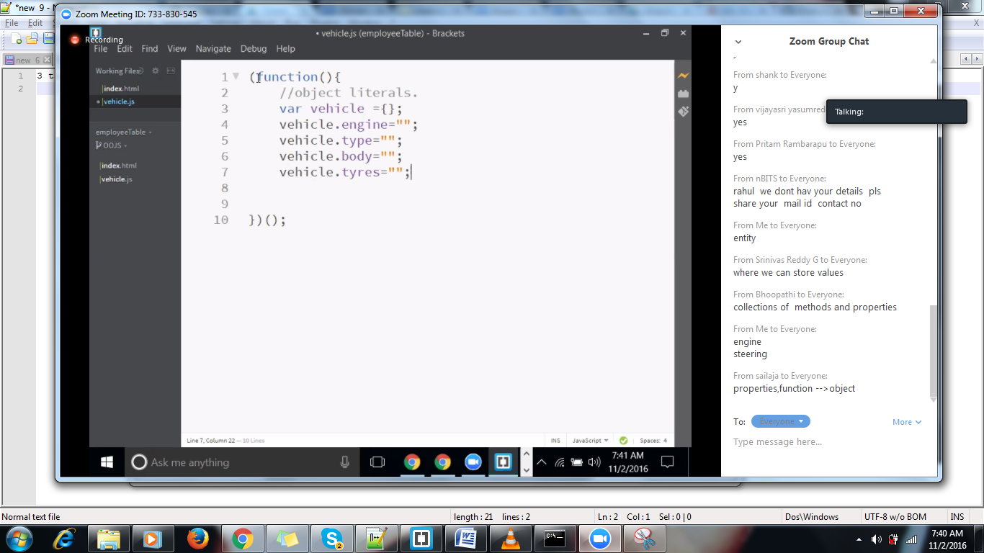

* Object literals can’t be extended, cant get instances out of obj literal
* If we know the structure, and doest nt gets change ,in such a case can go fr object literals
* Instantion,inheritance etc., can’t be done in object literals

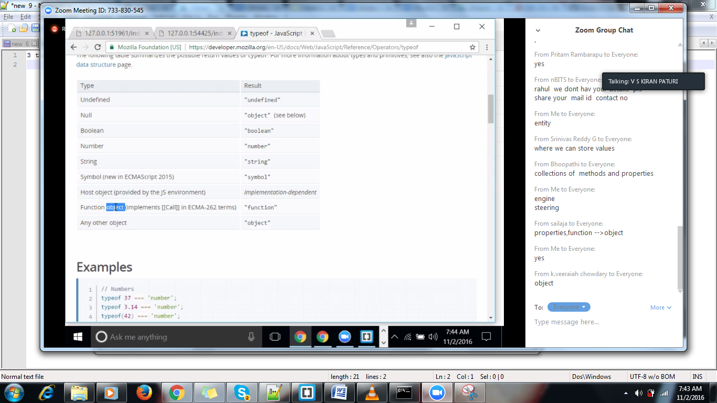

Function is also kind of object

For each object there will be memory allocating

Var bike=new vehicle (); //allocating same space to vehicle

For ex vehicle is having 10mb ,allocating same to bike.

Var car=new vehicle (); (this type of creation is called constructor based creation)

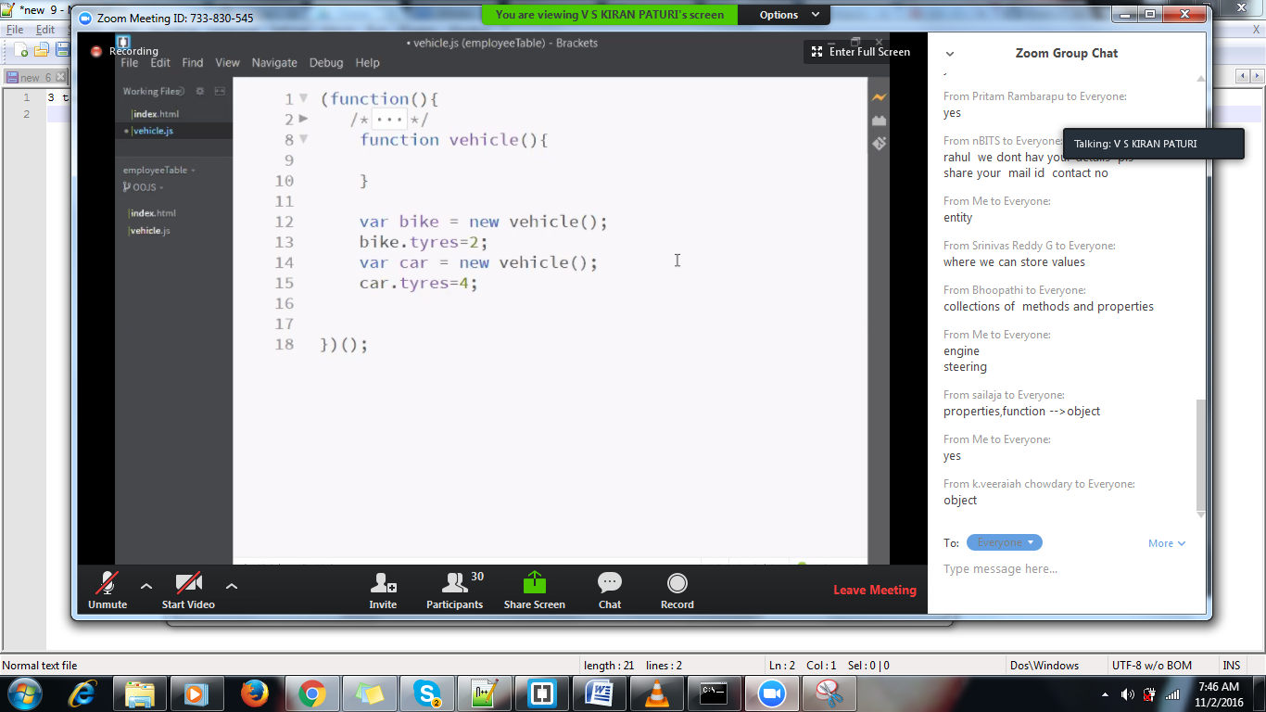

Constructor Function

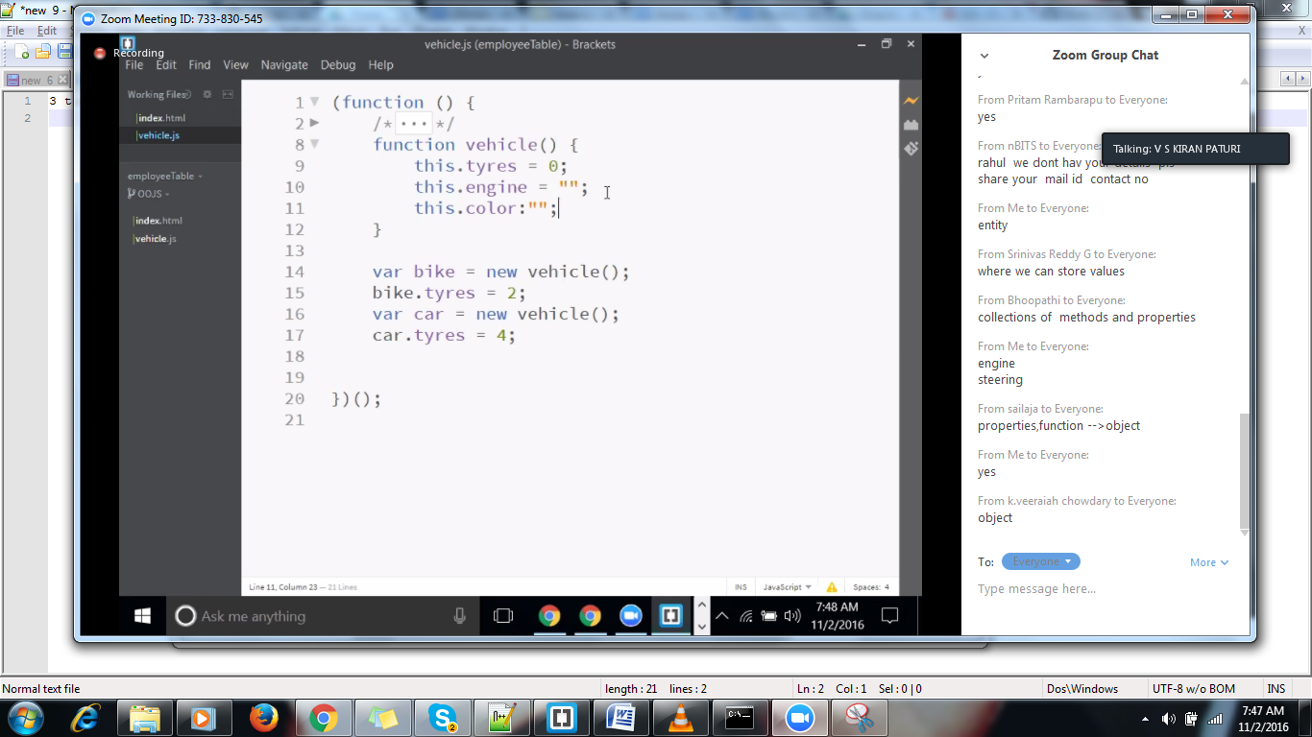

Lets check whether properties got extended to objects car and bike.

This refers to current reference/object.

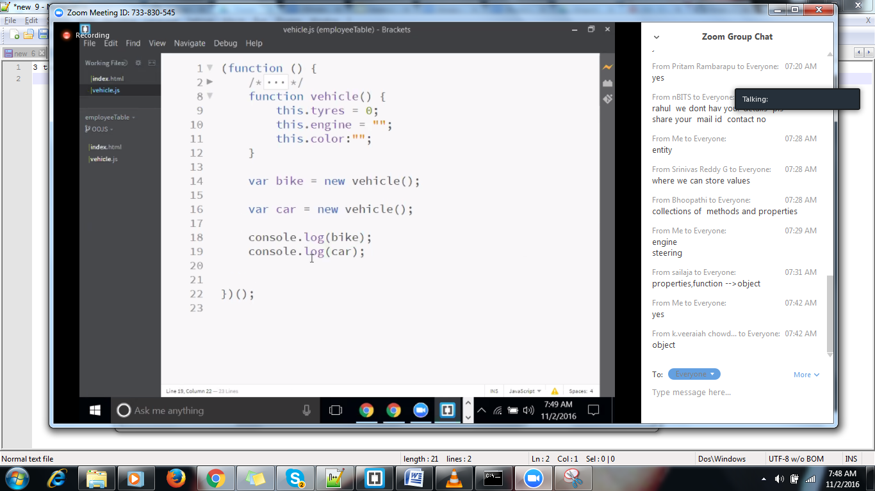

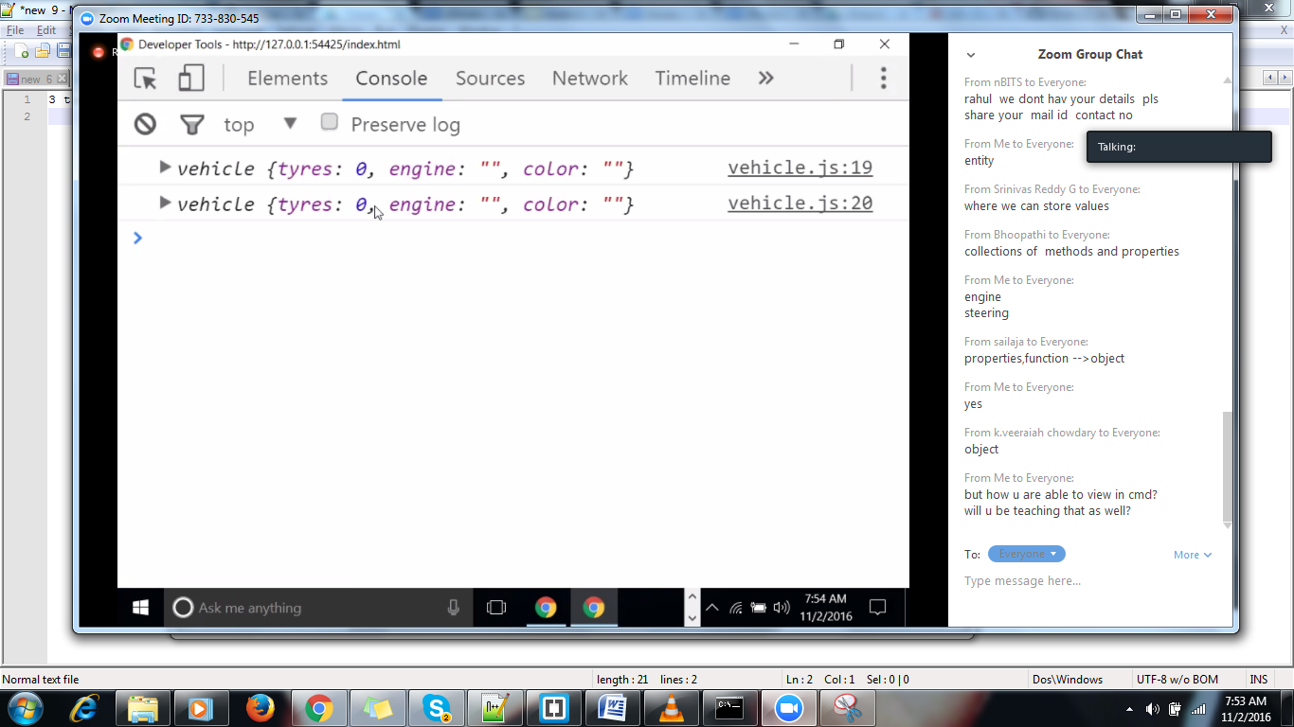

Diff b/w obj literal and constructor object

Var vin={} //Pivate property

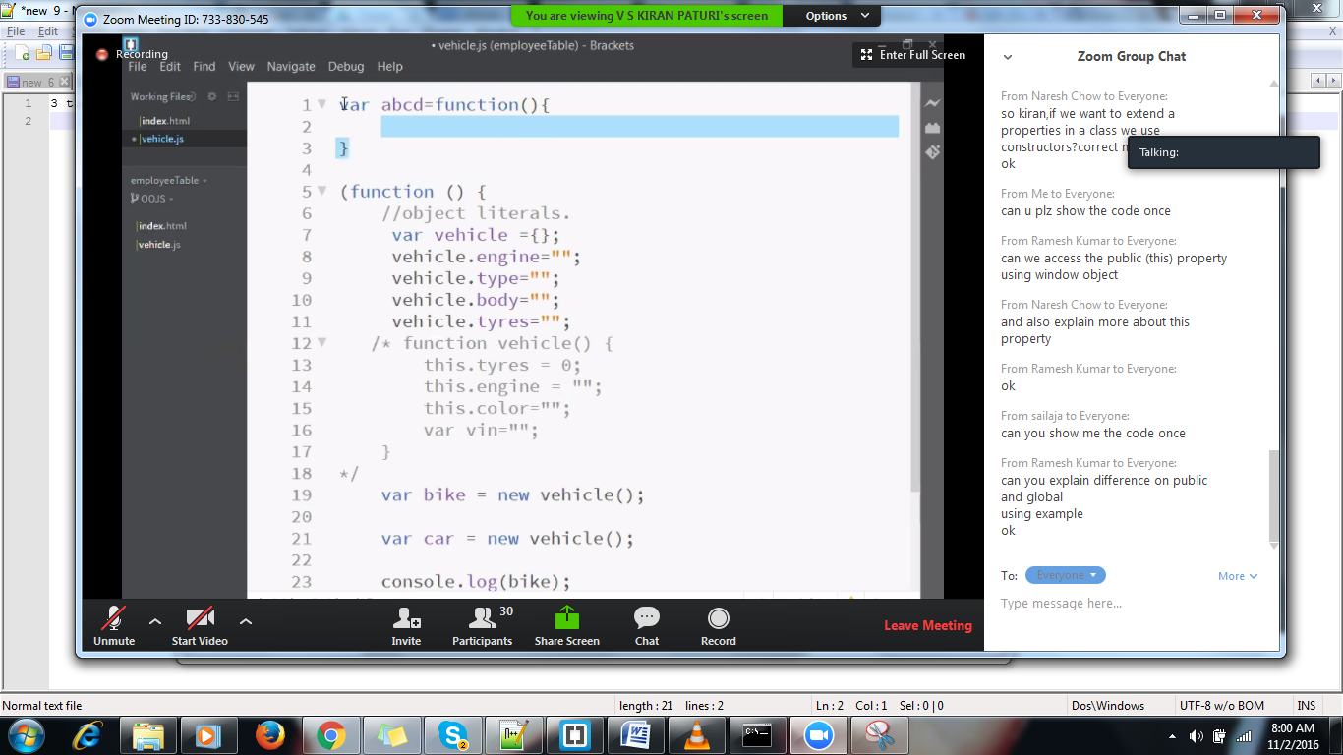

Window object (window.name-🡪Global prop)

Whereas engine, type, body-🡪 public prop)

